Steps to install sitecore 10

# IIS

Hit Start

Open the Start menu.

Type features and select Turn Windows features on or off.

Tick the Internet Information Services checkbox and hit OK.

Wait for the installation to complete and hit Close.

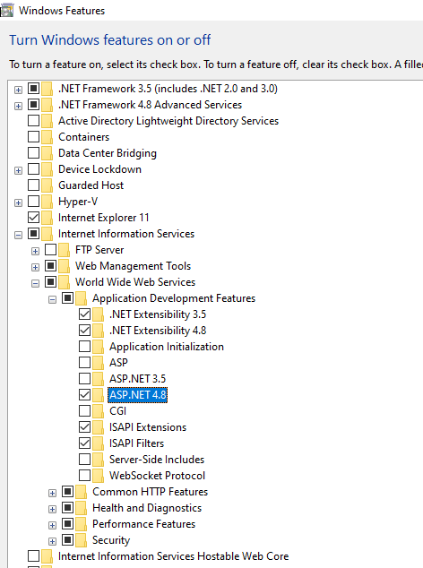

# Install Visual Studio 2019

<https://visualstudio.microsoft.com/thank-you-downloading-visual-studio/?sku=enterprise&rel=16&utm_medium=microsoft&utm_campaign=download+from+relnotes&utm_content=vs2019ga+button>

Check the boxes for ASP.Net, Azure Development, Universal Windows Platform Development

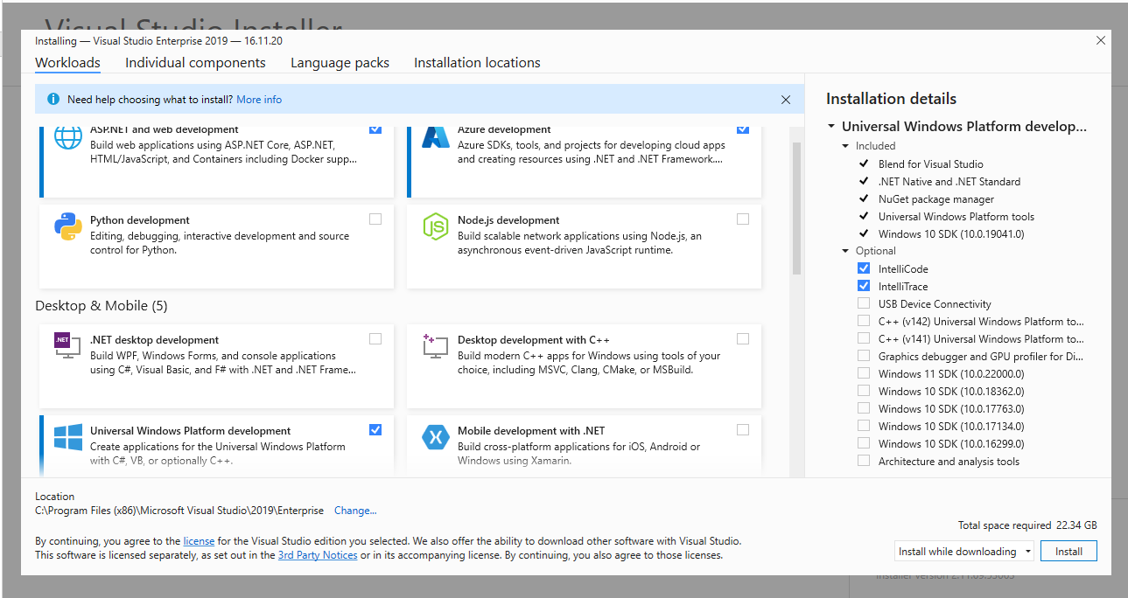

# SQL Server

Download SQL Server 2019 Standard from MSDN

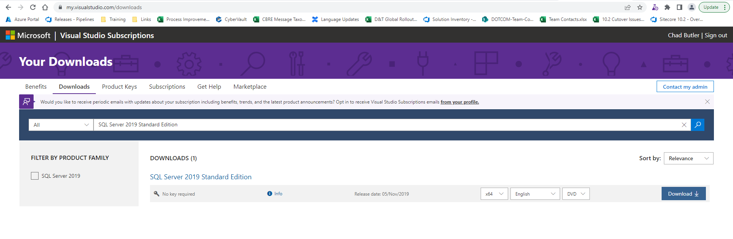

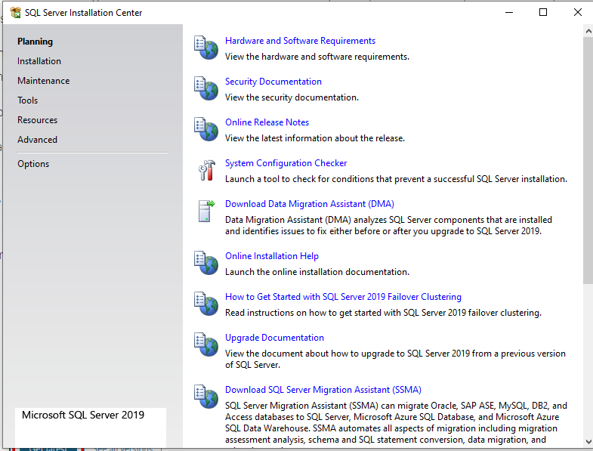

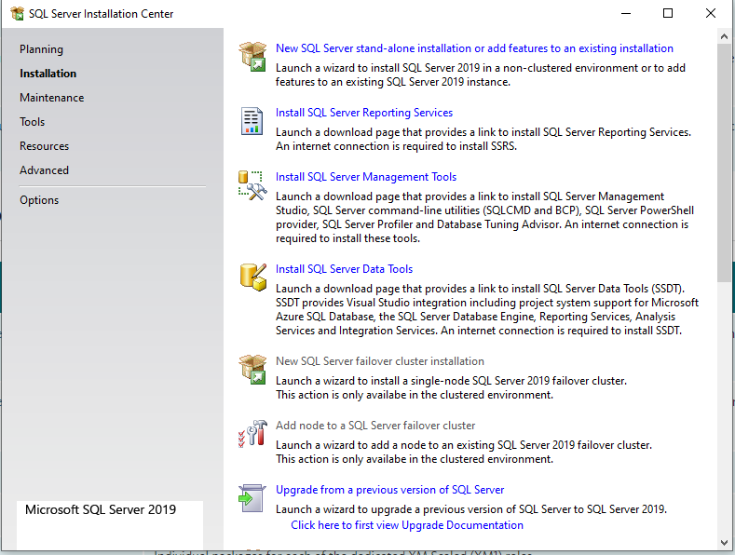

Install new standalone SQL Server

If not otherwise specified below just hit next or install

On the Feature selection, select Database Engine Services

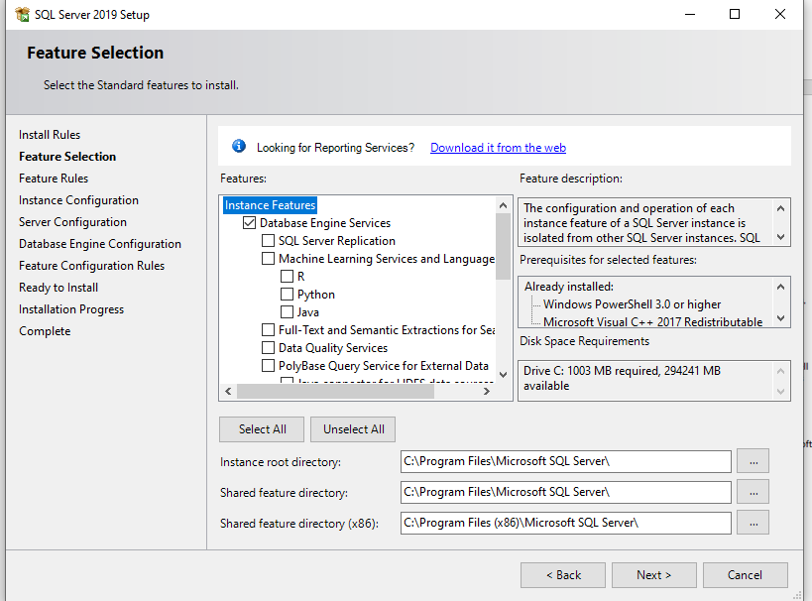

## Install SQL Server Management Tools

Download and Install sql Management tools

https://learn.microsoft.com/en-us/sql/ssms/download-sql-server-management-studio-ssms?redirectedfrom=MSDN&view=sql-server-ver16

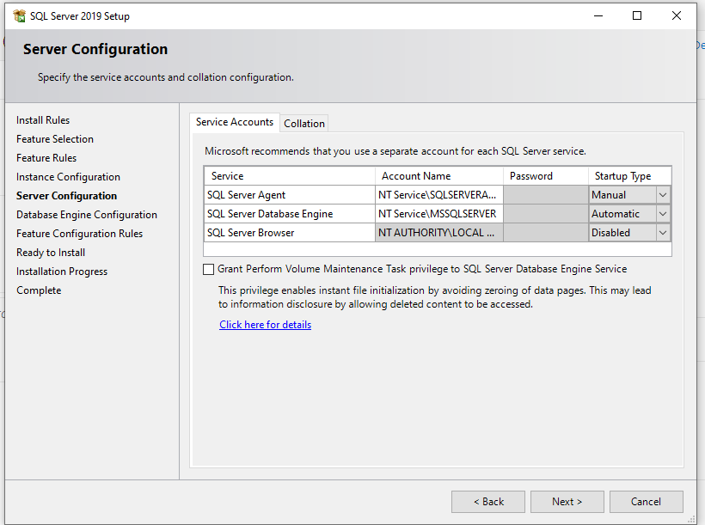

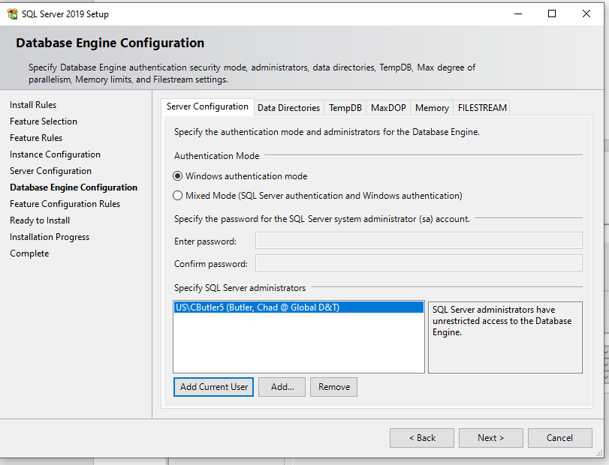

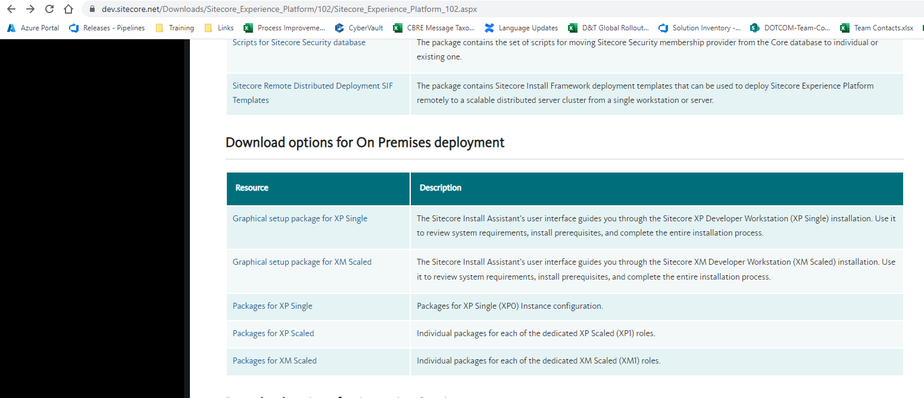

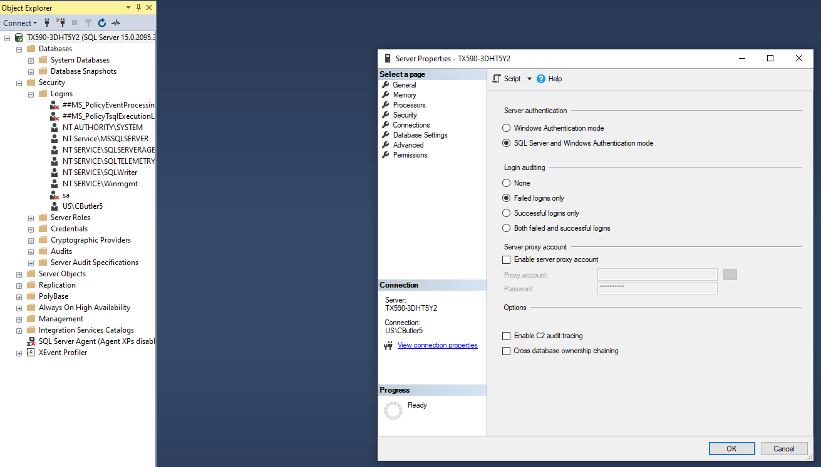

Right click on the sql server node and restart Sql Server

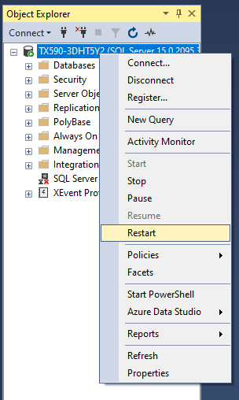

Double click on the sa user

Set the password on the sa user to the one you selected earlier

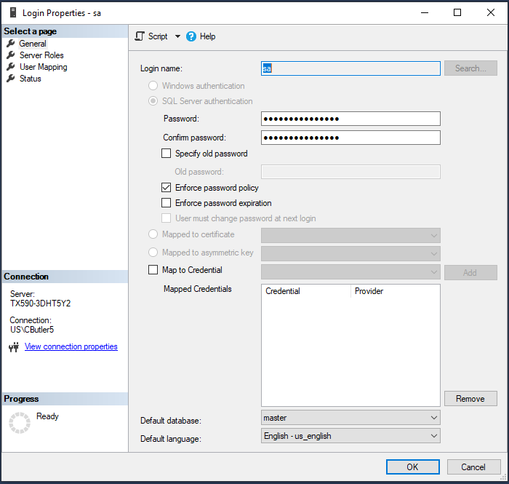

Enable the user on the status page

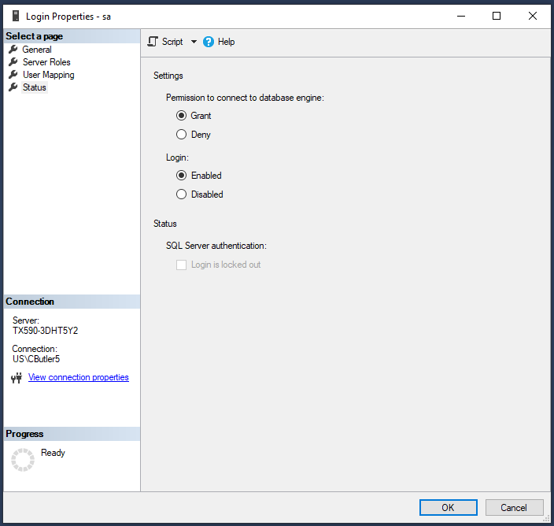

Hit ok

# Sitecore 10

Download Graphical Setup package for XP single

Solr:

Open file “Solr-SingleDeveloper.json” in notepad modify the apache URL’s value from http:// to https://

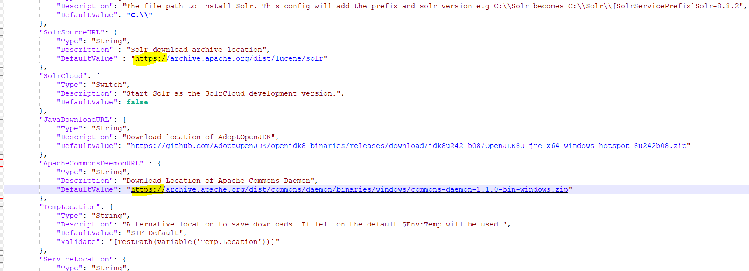

Launch as administrator

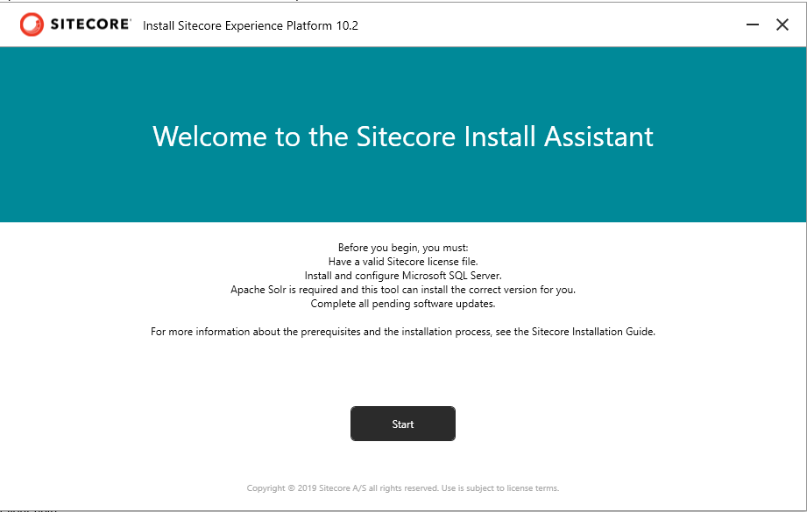

Install prerequisites

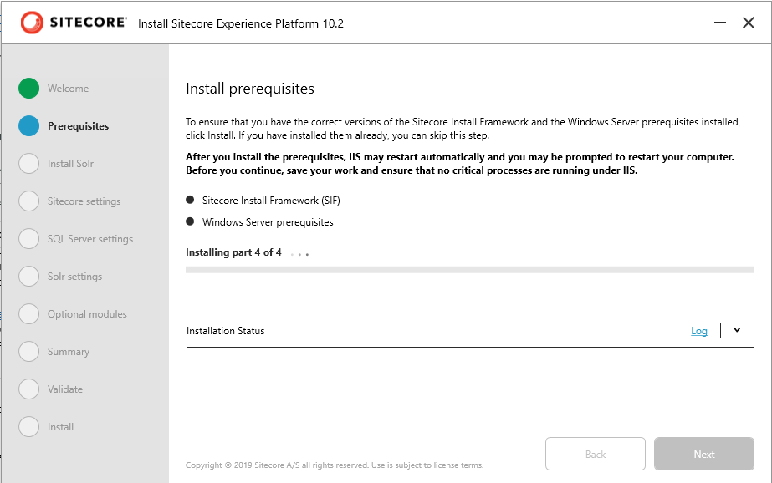

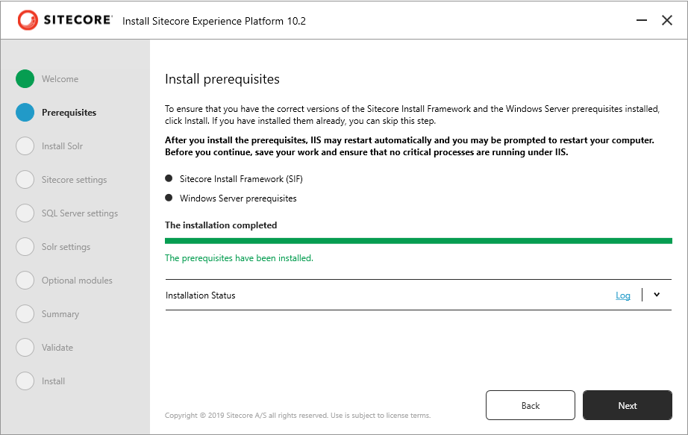

Skip the Solr Item

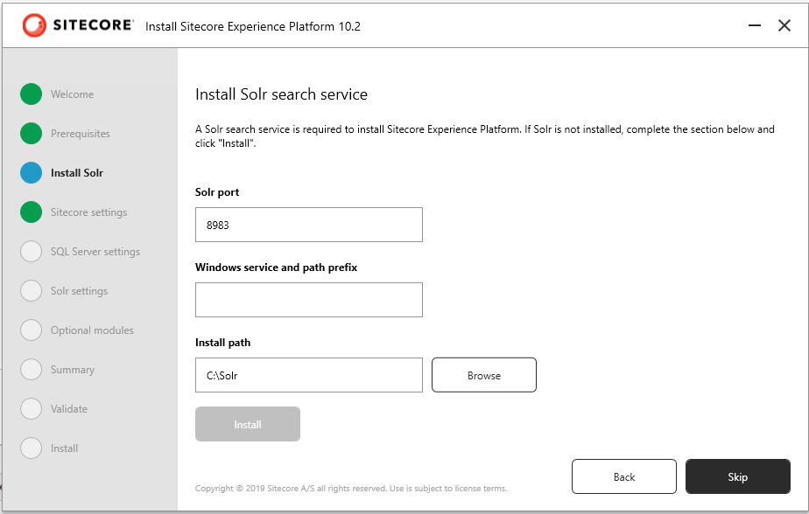

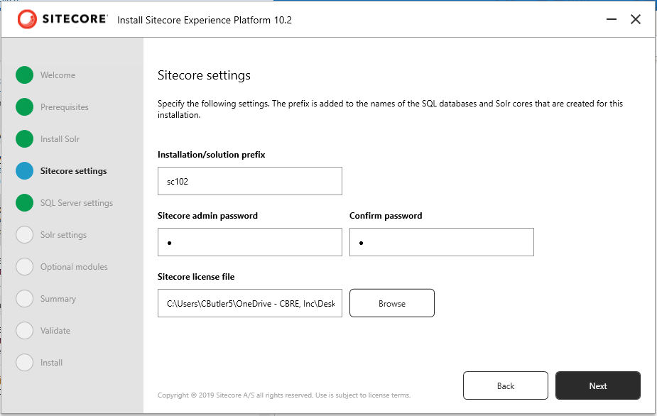

Sitecore Installation Prefix – sc102

Password, your choice or the standard “b”

Get the license file from your VM

Use your SQL SA password from an earlier step

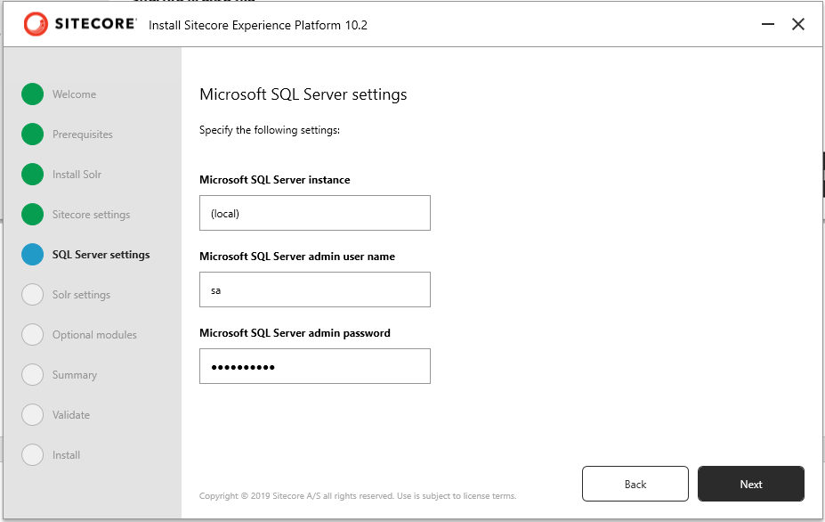

Change the port on the solr service URL to 8984

Solr File system root - C:\Solr882

Solr Windows service name - solr882

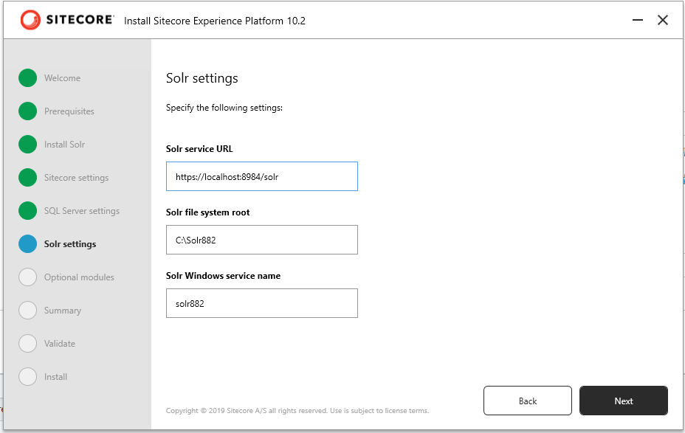

Check SXA

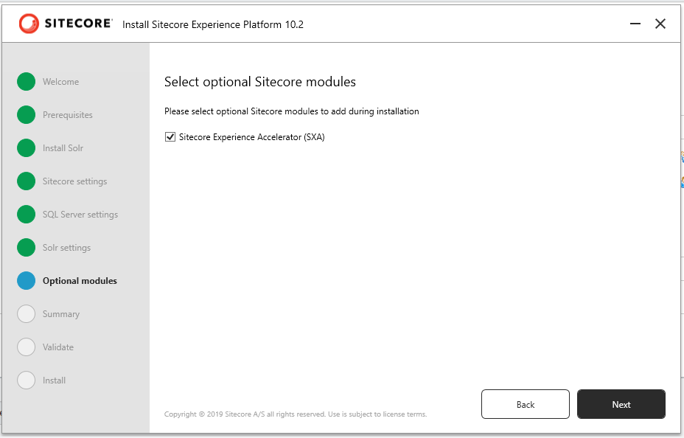

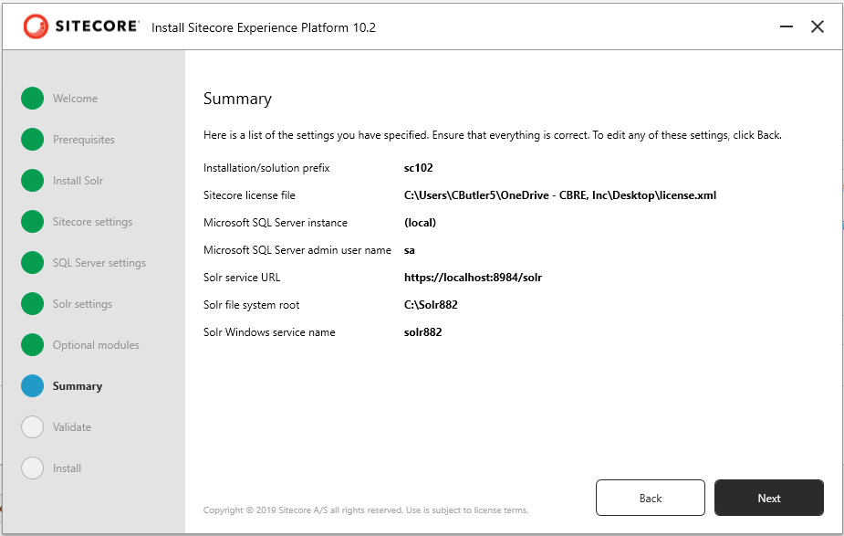

All should be green, hit install

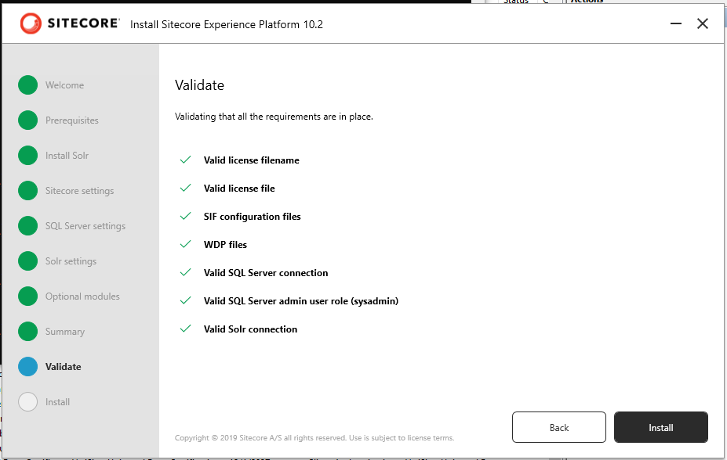

Make a backup of the c:\inetpub\wwroot\sc102.dev.local folder called sitecore vanilla

Open IIS and ensure that the service is started and that all sites are started

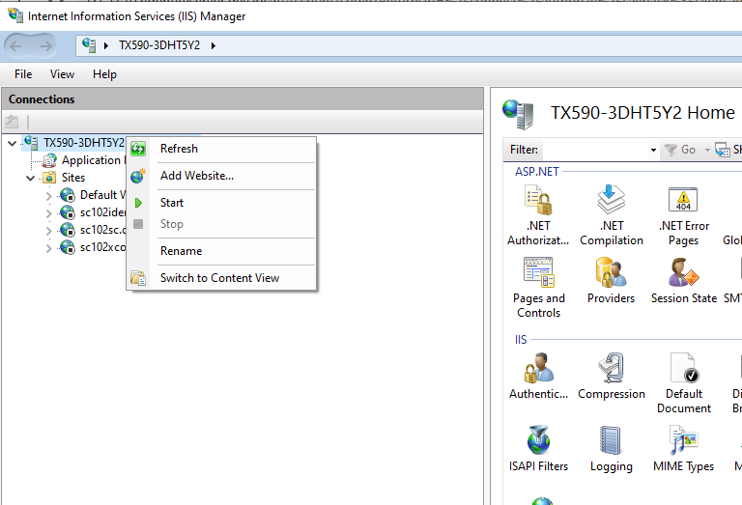

Clone the dotcom repository from Azure to c:\code\dotcom

Download the .net4.8 targeting pack from <https://dotnet.microsoft.com/en-us/download/dotnet-framework/thank-you/net48-developer-pack-offline-installer>

Install TDS 6.0.0.18, use the license code from your VM

Create an empty folder named GRG in your website root to avoid a GRG error

Get latest

Deploy normally

Sync TDS Templates, Layouts

Use Sidekick to pull down shared data, global site and any other data you need from PREPROD